8-BIT MULTIPLICATION

EXP NO: 3

AIM:To write an assembly language program to
implement 8-bit multiplication using 8085 processor.

ALGORITHM:

1) Start
the program by loading a register pair with the address of memory location.

2) Move
the data to a register.

3) Get
the second data and load it into the accumulator.

4) Add
the two register contents.

5) Increment
the value of the carry.

6) Check
whether the repeated addition is over.

7) Store
the value of product and the carry in the memory location.

8) Halt.

PROGRAM:

LDA 8500

MOV B, A

LDA 8501

MOV C, A

CPI 00

JZ LOOP

XRA A

LOOP1: ADD B

DCR C

JZ LOOP

JMP LOOP1

LOOP: STA 8502

RST
1

INPUT:
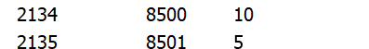

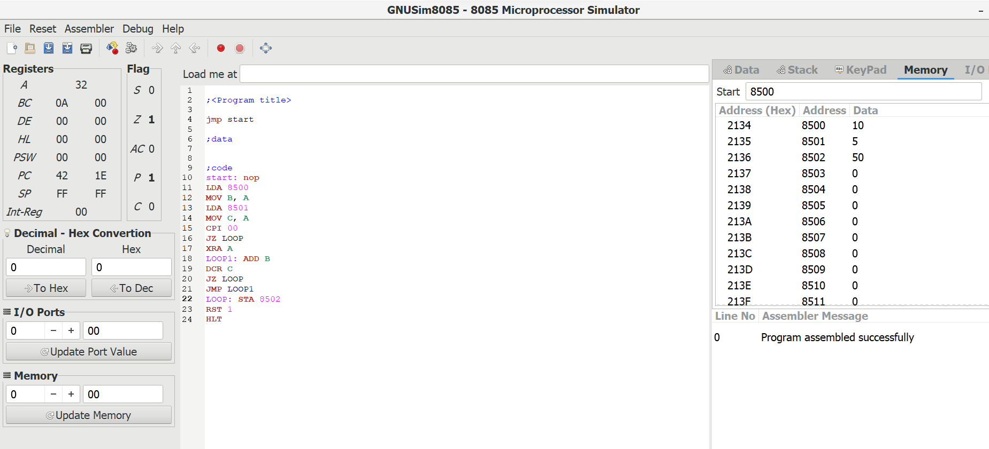

OUTPUT:

RESULT:Thus the program was executed successfully
using 8085 processor simulator.
Class comments

